**ASSIGNMENT**

**MODULE-4**

**ROUTE 53**

**DONE BY**

**RANJITH KUMAR**

**Tasks To Be Performed:**

1. Use the Route 53 hosted zone created in the assignment.

2. Route the traffic to an EC2 instance with an Apache web server running in

it using its IP address.

**STEP 1 :** Open Route53 from aws services

**STEP 2 :** Select Domain > Register Domain to get a domain

**STEP 3 :** In search for a domain box search the domain that we need to use .

Domain will be listed down and we select the domain for our use

And procced the payment to get the domain

I did not purchase the domain

**STEP 4 :** Then select Hosted Zone > Create Hosted Zone

**STEP 5 :** Give Domain name and type of hosted zone.I have choosen Public hosted zone

**STEP 6 :** Hosted Zone Created

**STEP 7 :** Create a EC2 instance with Apache webserver running in it

**STEP 8 :** In hosted zone create a record

**STEP 9 :** Copy the Public ip address of the EC2 instance and use in records

**STEP 10 :** Records have been created

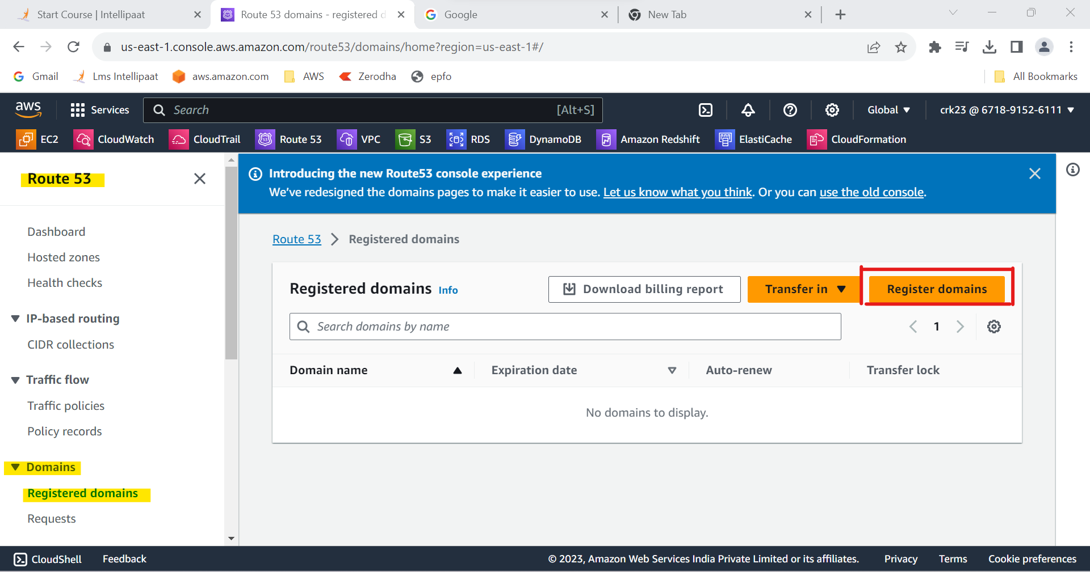

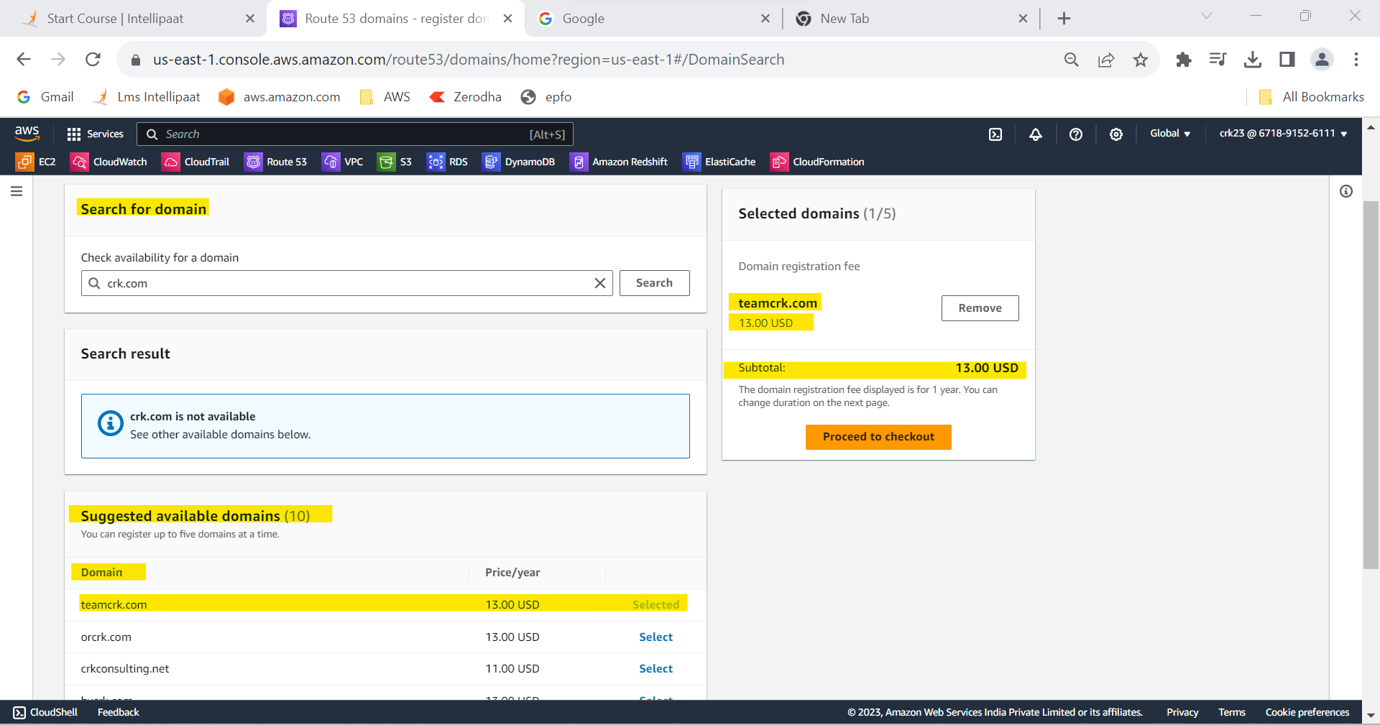

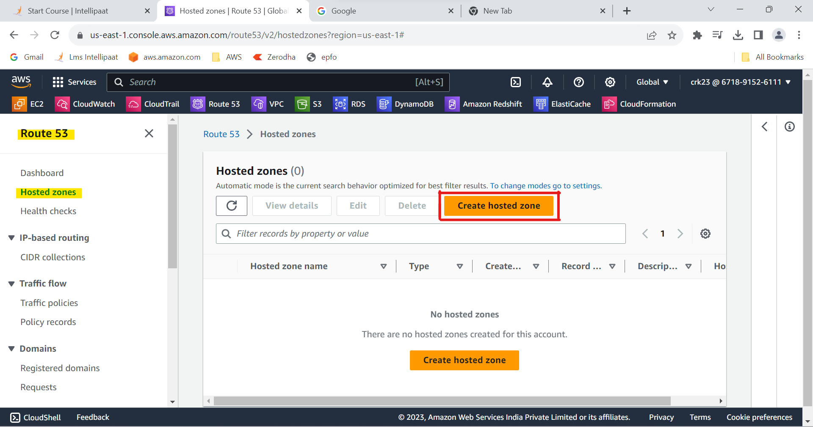

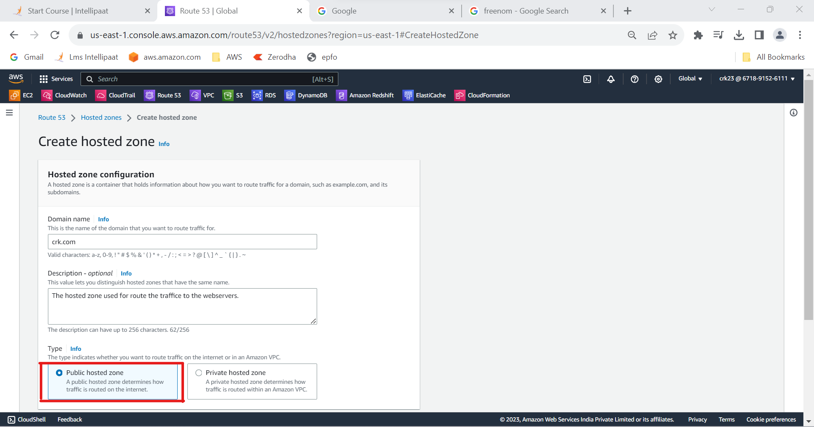

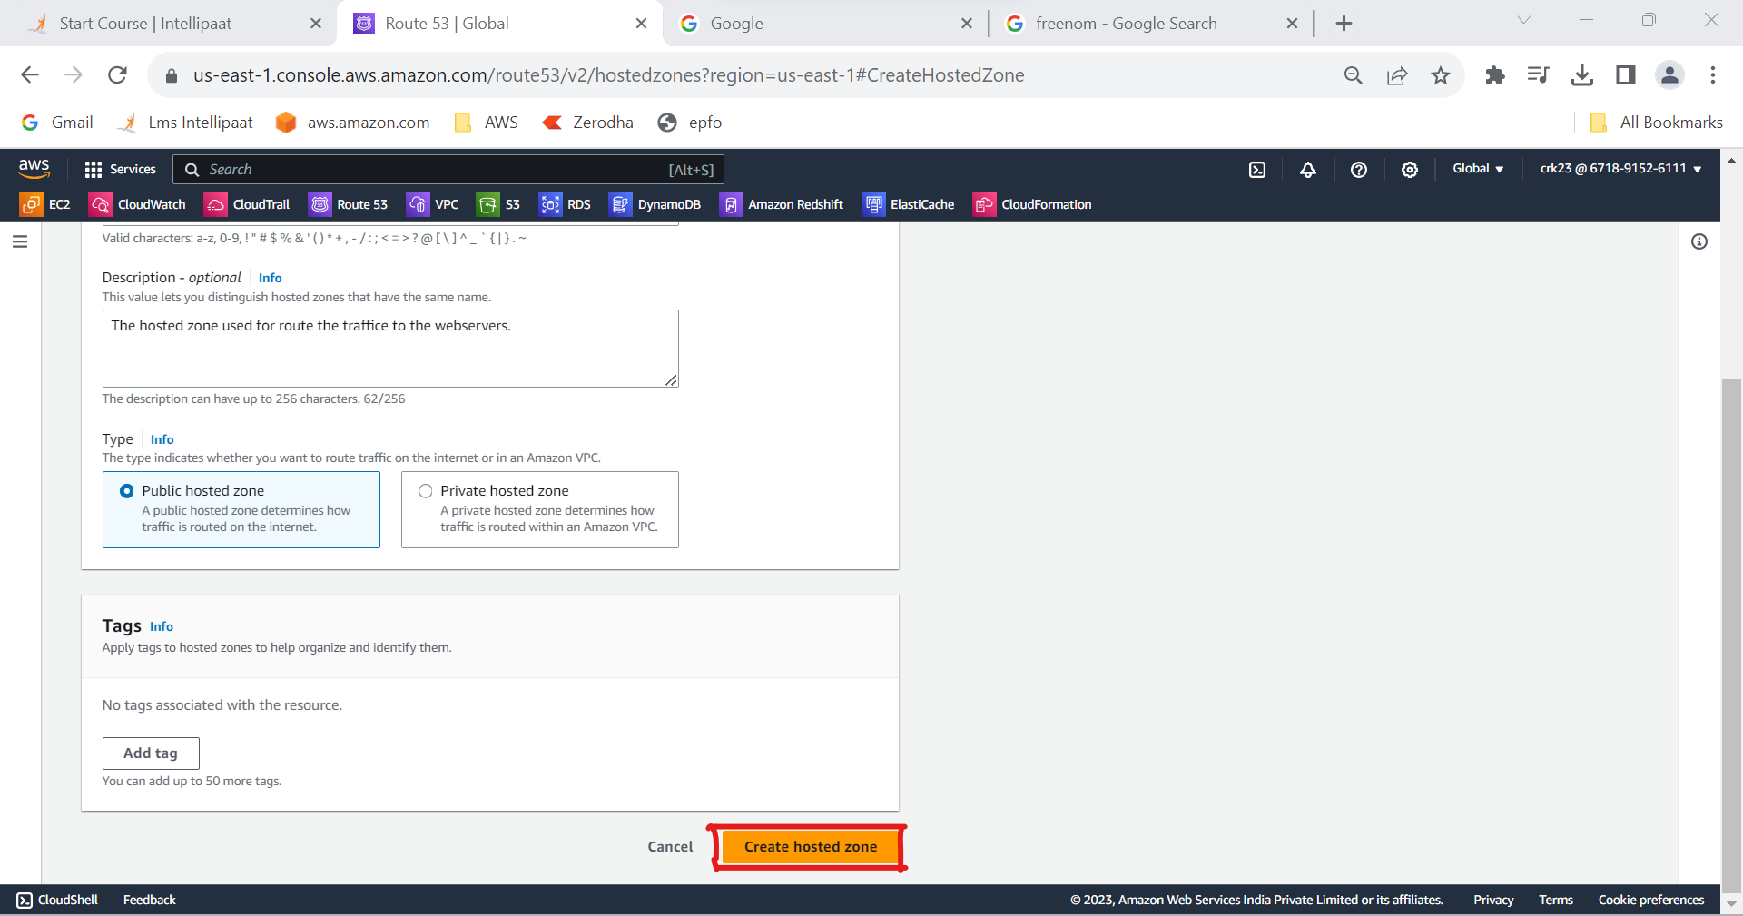

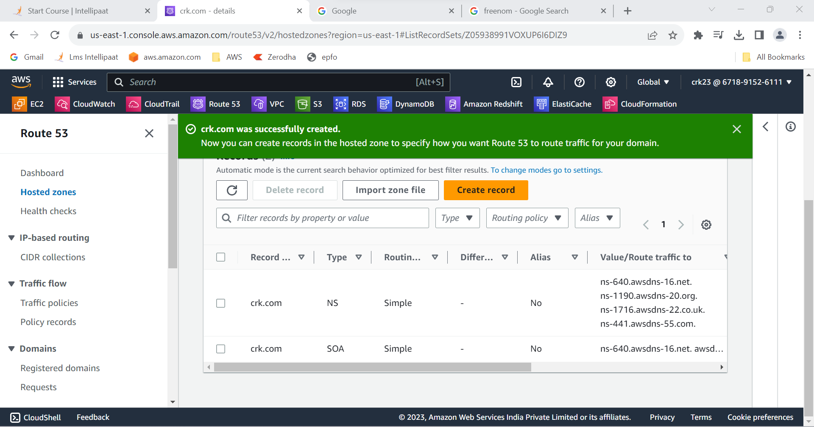

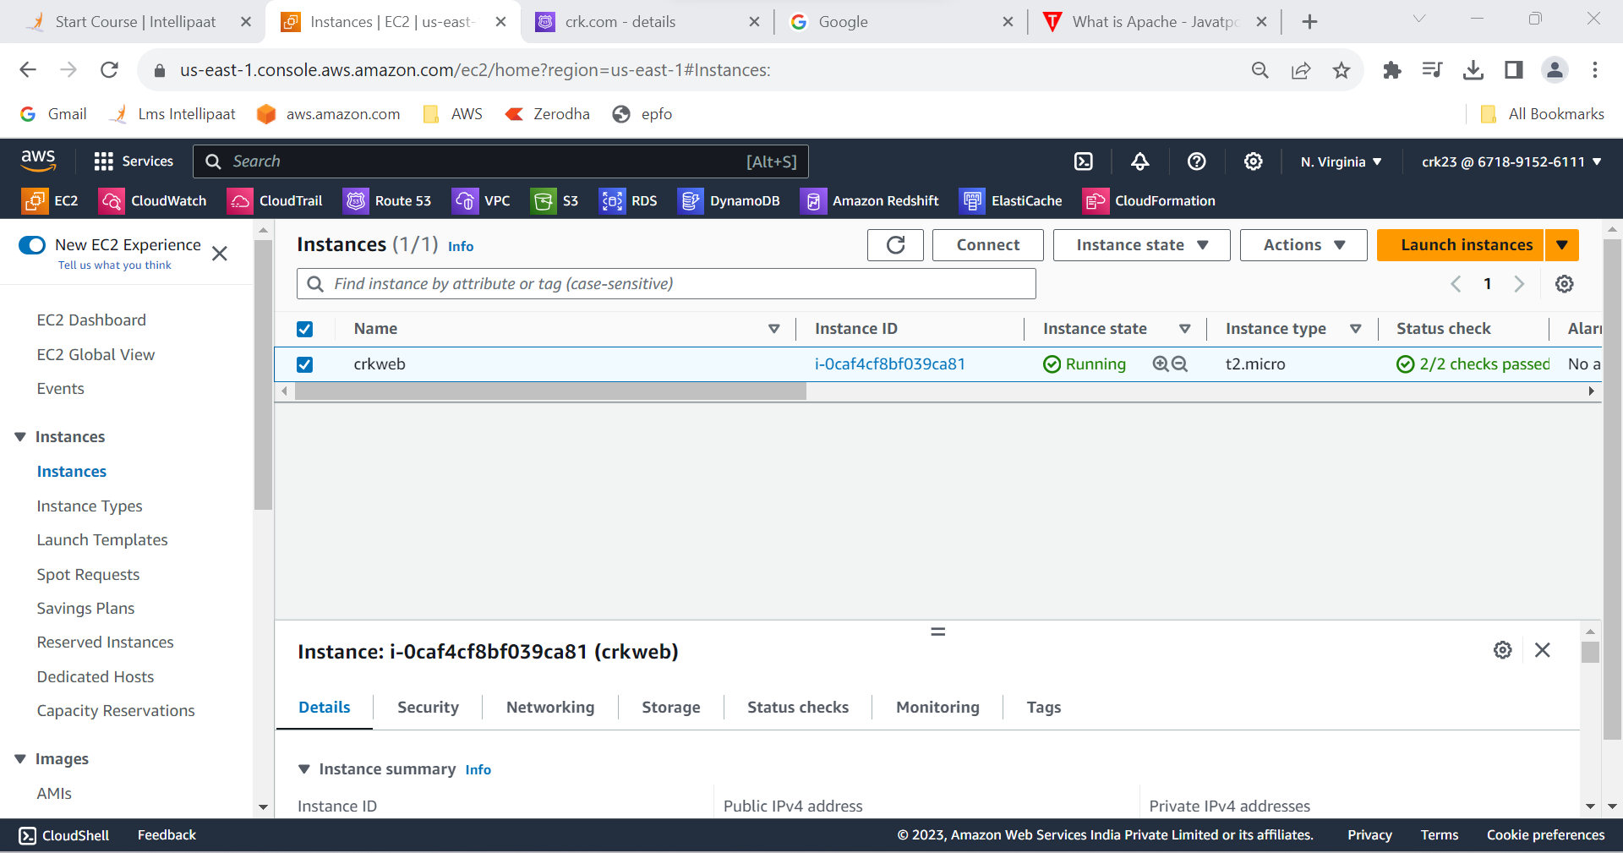

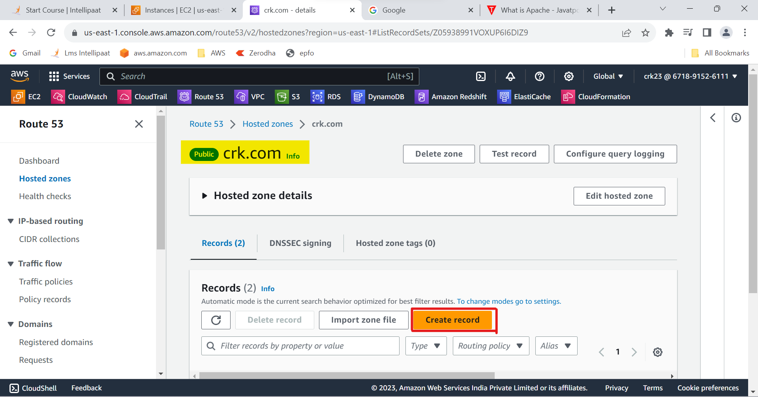

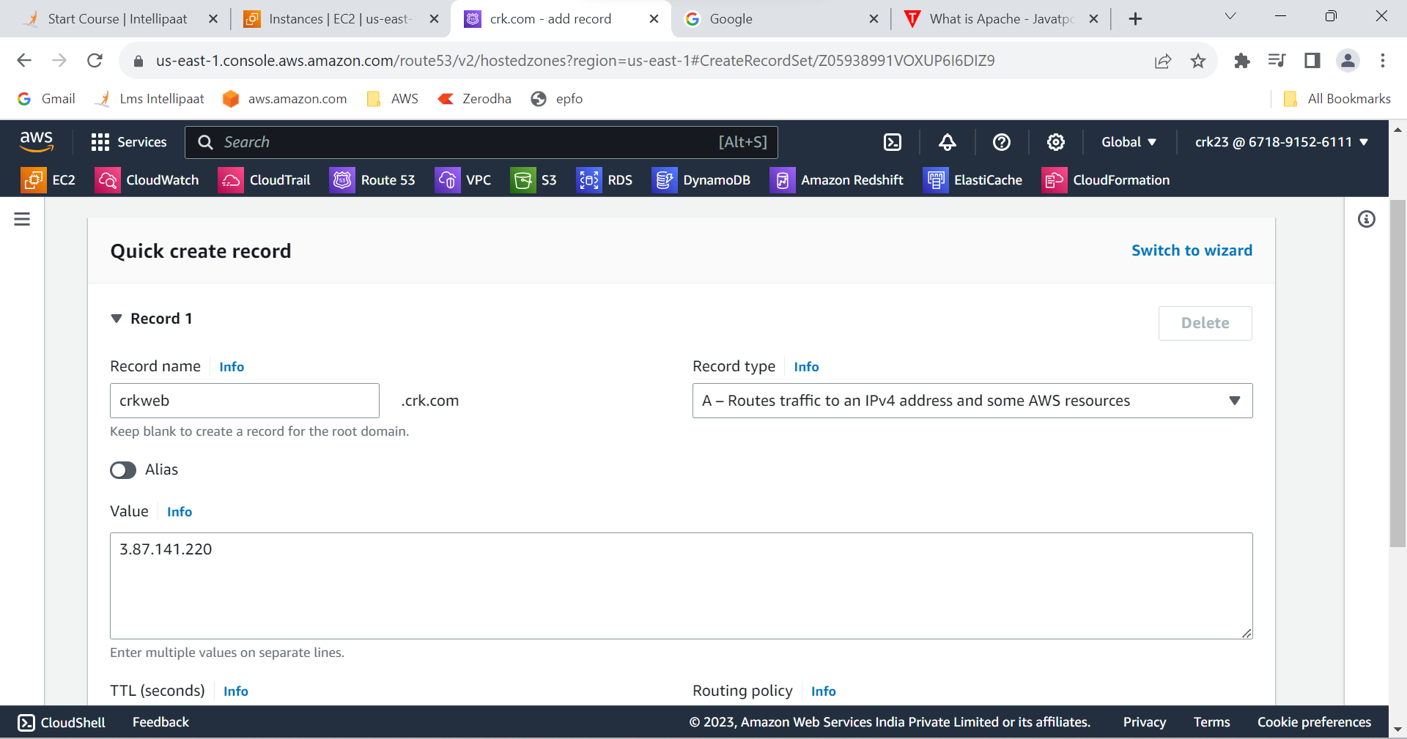

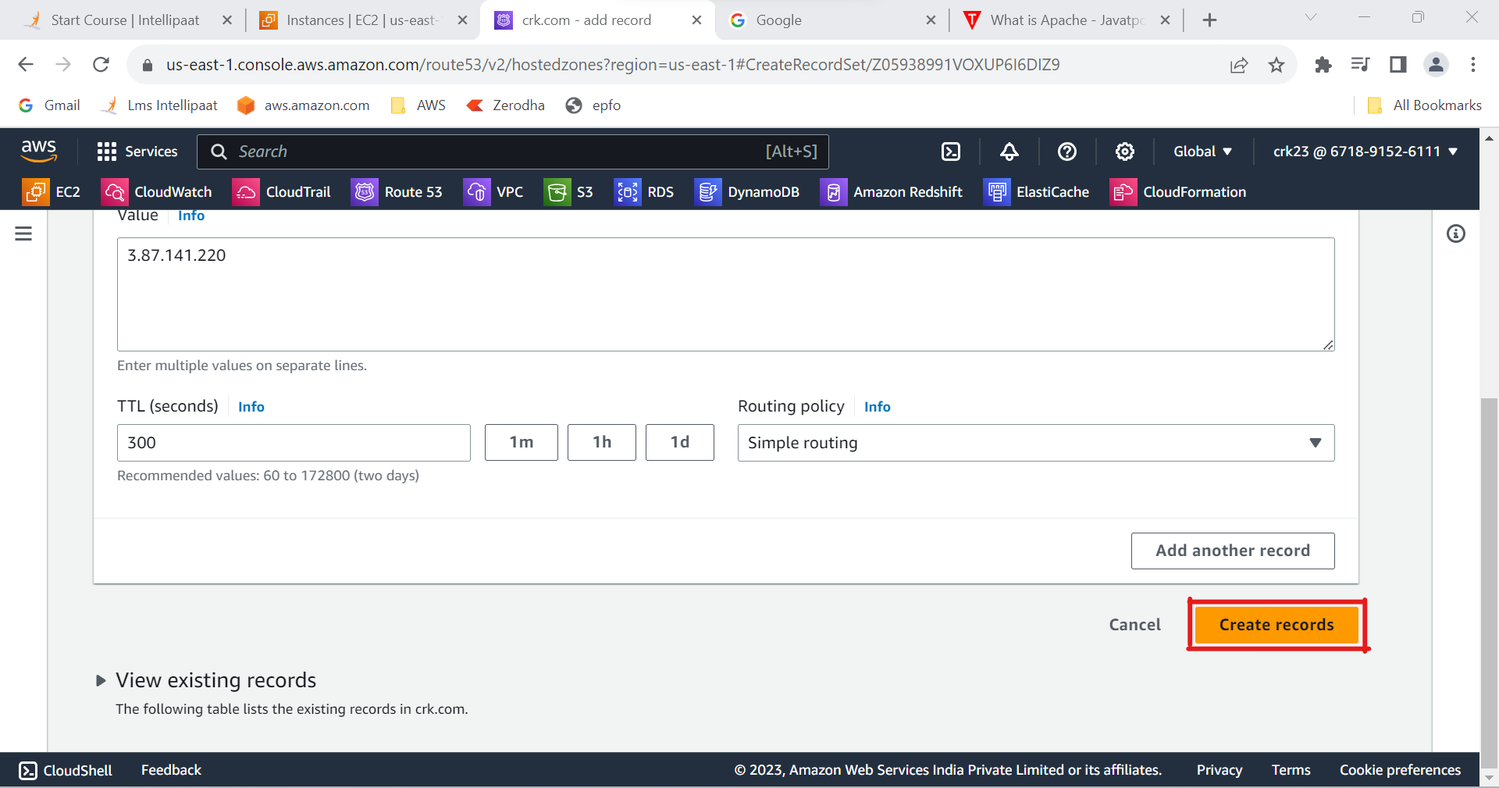

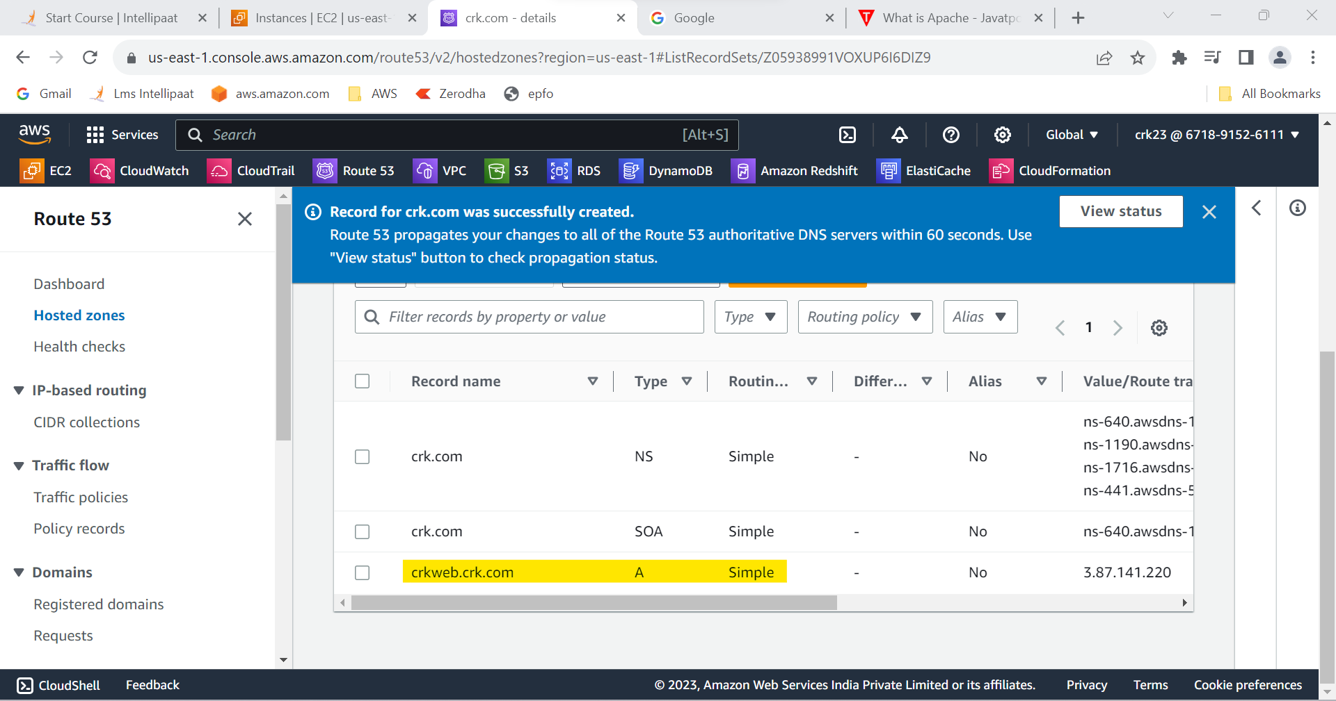

**OUTPUT :**

Used the Route 53 hosted zone created in the assignment and Routed the traffic to an EC2 instance with an Apache web server running in

it using its IP address.